Classroom Activity: Introduction to Azure Portal

The steps for getting started with Azure Portal in detail:

# Sign Up:

* + To begin using the Azure Portal, you need an Azure account. If you don't have one, you can sign up for either a free trial or a paid subscription.
  + A free trial typically offers a limited amount of Azure credits that you can use to explore Azure services. It's an excellent option for beginners to get started without incurring costs.
  + For a paid subscription, you'll be billed based on your actual usage of Azure services. You can choose a subscription plan that suits your needs.
  + You can also use the provided access which is exclusive for the students of Techsaksham. For this you can refer the shared mail on MS Azure access from Edunet Foundation.

# Log In:

* + Once you have an Azure account, you can log in to the Azure Portal. You'll use your Microsoft account credentials for this.

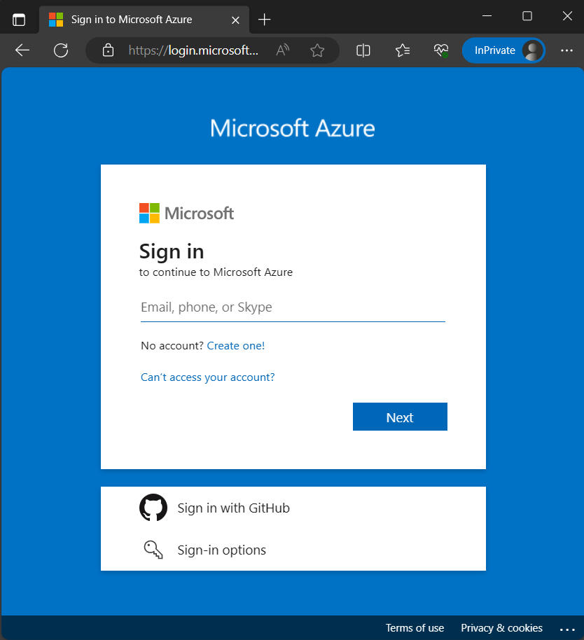

# Dashboard:

* + After logging in, you'll be greeted by the Azure Portal dashboard. This dashboard is your central hub for managing and monitoring all your Azure resources and services.

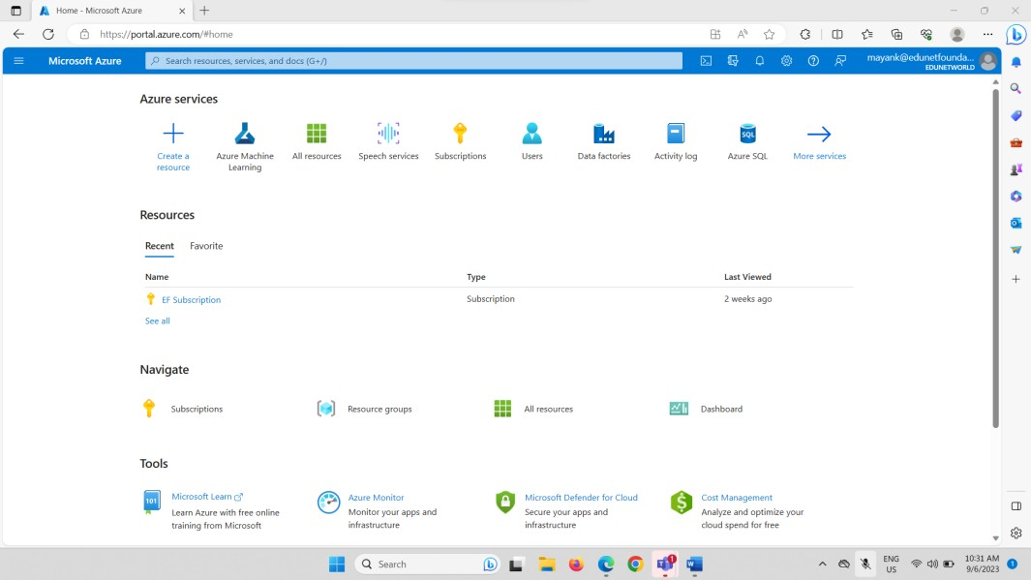

* + It provides an overview of your resources at a glance, displaying information such as recent activity, notifications, and key metrics.
  + The dashboard is highly customizable. You can pin specific resources, charts, or services to it, tailoring it to your preferences and needs.

# Browse Services:

* + On the left sidebar of the Azure Portal, you'll find a menu that lists various Azure services and resources. This menu serves as your navigation tool to access different services.

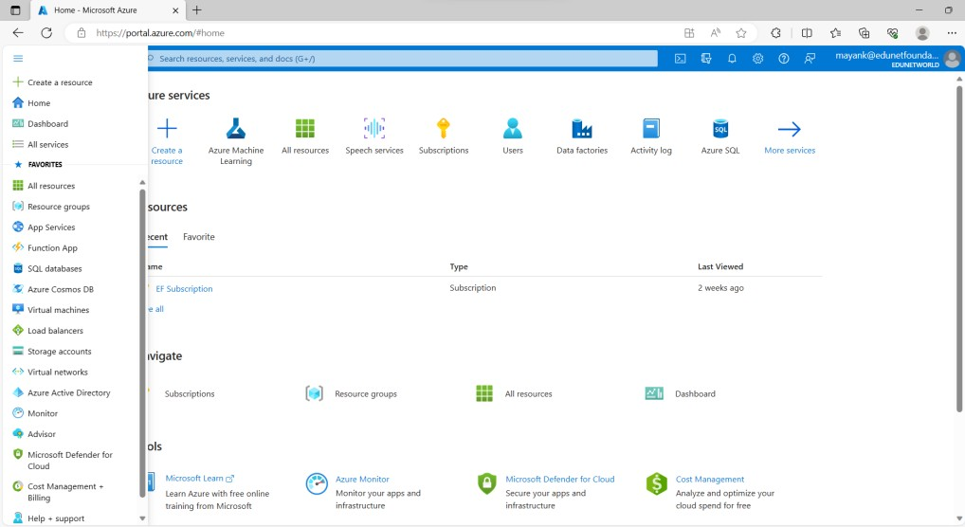

* + Azure offers a wide array of services, including virtual machines, databases, storage, AI, IoT, and more. You can explore these services by clicking on the categories and drilling down to specific services.
  + Each service typically has its own dashboard, settings, and management options.

# Resource Creation:

* + To gain hands-on experience with Azure, you can start by creating your first Azure resource. This could be a virtual machine, a web app, a database, or any other service that suits your project or learning goals.
  + To create a resource, click on the "Create a resource" button in the Azure Portal. You'll be guided through a wizard where you can choose the type of resource you want to create, configure its settings, and deploy it.

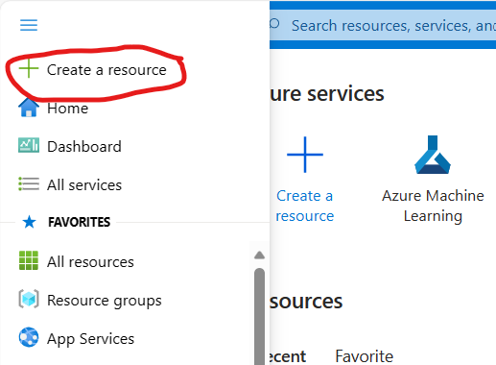

* + Azure provides templates and recommendations to simplify the resource creation process.